

A MINI PROJECT REPORT
on
WEB DESIGN TECHNOLOGIES (24CSE361)
PORTFOLIO WITH IMAGE HOVER
EFFECTS
Submitted by
HUSSAINGARI DHAFIA – 1NH24CS091

Under the guidance of

Ms. Divyanshi Chhabra

Assistant Professor

In partial fulfillment for the award of the degree of

BACHELOR OF ENGINEERING
in
COMPUTER SCIENCE AND ENGINEERING
Academic Year: 2025-26 (ODD SEM)

CERTIFICATE

This is to certify that the mini project work titled “Portfolio with image Hover effects” is a Bonafide work carried out by Name of the student (1NH24CS091) in partial fulfillment of the degree of Bachelor of Engineering in Computer Science and Engineering of the New Horizon College of Engineering during the year 2025-2026.

Signature of Guide Signature of HOD

SEMESTER END EXAMINATION

Name of the Examiner Signature with date

1.

2.

ABSTRACT
In the digital era, individuals — especially students and early-career professionals — increasingly require a strong online presence to showcase their achievements, technical expertise, and personal projects. A portfolio website serves as a modern alternative to a traditional resume by offering interactive and visually rich access to credentials and project work. This mini-project focuses on the design and development of a personal portfolio website integrated with image hover effects, which enhance user interaction and improve the overall engagement of the viewer.
The development process uses a front-end web technology stack wherein HTML is responsible for designing the basic structure, layouts, and divisions across the webpage [1], CSS ensures the visual presentation through attractive colour themes, animations, responsive grid layouts, and smooth hover transitions on project images [2], and JavaScript is utilized to provide interactivity including typing text animation, dynamic behaviour on user actions, and responsive control messages for the contact form [3].
To improve the professional appearance and readability of the site, Google Fonts API is used to import custom typography styles [4], while Font Awesome Icons API supplies aesthetic icons that enable quick access to GitHub and LinkedIn profiles [5]. The website is additionally built with a responsive design approach so that it automatically adjusts to different screen sizes including laptops, tablets, and mobile devices without losing layout consistency [2].
The final output of the project is a highly polished digital portfolio capable of representing personal profile, skills, experience, and project highlights in an appealing and interactive way. The implementation demonstrates how modern web development tools and APIs can be leveraged to build a compact yet professional online identity suitable for academic presentations, internship applications, and campus placements. Overall, this mini-project successfully shows how frontend technologies can transform static information into an engaging personal branding platform that enhances career opportunities in the digital world.

ACKNOWLEDGEMENT
The satisfaction and euphoria that accompany the successful completion of any task would be impossible without the mention of the people who made it possible, who’s constant guidance and encouragement crowned our efforts with success.

I have great pleasure in expressing gratitude to Dr. Mohan Manghnani, Chairman, New Horizon Educational Institutions, for providing necessary infrastructure and creating good environment.

I take this opportunity to express my profound gratitude to Dr. Manjunatha, Principal, New Horizon College of Engineering, for the constant support and encouragement.

I would like to thank Dr. Anandhi R J, Professor and Dean-Academics, NHCE, for her valuable guidance.

I would also like to thank Dr. B. Rajalakshmi, Professor and HOD, Department of Computer Science and Engineering, for the constant support.

I also express my gratitude to Ms. Divyanshi Chhabra
, Assistant Professor, Department of Computer Science and Engineering, my mini project reviewer, for constantly monitoring the development of the project and setting up precise deadlines. Her valuable suggestions were the motivating factors in completing the work

Hussaingari Dhafia
1NH24CS091

CONTENTS
ABSTRACT | I
ACKNOWLEDGEMENT | II
CONTENTS | III
LIST OF FIGURES | V
- INTRODUCTION | 1
1.1 PROBLEM DEFINITION | 1-2
- OBJECTIVES | 3
1.3 METHODOLOGIES TO BE FOLLOWED | 4-5
- FUNDAMENTALS OF THE LANGUAGES USED | 6
2.1 HTML | 6
2.2 HTML TAGS | 6-8
2.3 CSS  2.4 JavaScript | 9-10  11-12
- REQUIREMENT SPECIFICATION | 13
3.1 HARDWARE REQUIREMENTS | 13
3.2 SOFTWARE REQUIREMENTS | 14
- DESIGN | 15
4.1 DESIGN GOALS | 15-16
- IMPLEMENTATION | 17
5.1 HOME PAGE | 17
5.2 NAVBAR | 17

5.3  5.4  5.5  5.6  5.7  5.8  5.9  5.10  5.11  5.12  5.13  5.14  5.15  5.16  5.17 | ABOUT SECTION  PROJECT SECTION  CONTACT SECTION  FOOTER SECTION  GLOBAL STYLING  NAVIGATION BAR STYLING  HOME SECTION STYLING  PROJECT SHOWCASE STYLING  OVERLAY EFFECT STYLING  CONTACT FORM STYLING  FOOTER AND SOCIAL MEDIA ICON  RESPONSIVE DESIGN FOR MOBILES  TYPING ANIMATION  CONTACT FORM STATUS MESSAGE  SMOOTH SCROLL | 18  18-19  19  19  20  20  21  21  22  22-23  23  23  24  24  24
- RESULTS |  | 25
6.1 | HOME PAGE | 25
6.2 | ABOUT SECTION | 25-26
6.3  6.4  6.5  6.6 | PROJECTS SHOWCASE  CONTACT SECTION  FOOTER SECTION  RESPONSIVENESS RESULT | 26  26-27  27  28
- CONCLUSION |  | 29
REFERENCES 30

LIST OF FIGURES

Figure No. | Description | Page No.
5.1.1 | CODE SNIPPET FOR HOME PAGE LAYOUT | 17
5.2.1 | CODE SNIPPET FOR NAV BAR | 17
5.3.1 | CODE SNIPPET FOR ABOUT SECTION | 18
5.4.1 | CODE SNIPPET FOR PROJECT SECTION | 18
5.5.1 | CODE SNIPPET FOR CONTACT SECTION | 19
5.6.1 | CODE SNIPPET FOR SOCIAL MEDIA ICONS | 19
5.7.1 | CODE SNIPPET FOR GLOBAL SECTION | 20
5.8.1 | NAV BAR STYLE | 20
5.9.1 | HOME STYLE | 21
5.10.1 | PROJECT SHOWCASE STYLE | 21
5.11.1 | OVERLAY EFFECT | 22
5.12.1 | CONTACT FORM | 22
5.13.1 | FOOTER AND ICONS | 23
5.14.1 | RESPONSIVE DESIGN | 23
5.15.1 | TYPING ANIMATION | 24
5.16.1 | FORM STATUS MESSAGE | 24
5.17.1 | SMOOTH SCROLL | 24
6.1.1 | OUTPUT OF HOMEPAGE | 25
6.2.1 | OUTPUT OF ABOUT SECTION | 26
6.3.1 | OUTPUT OF PROJECT SECTION | 26
6.4.1 | OUTPUT OF CONTACT PAGE | 27
6.5.1 | FOOTER SECTION | 27
6.6.1 | OUTPUT OF RESPONSIVE VIEW ON MOBILE | 28

LIST OF TABLES

Table No. | Description | Page No.
2.1.1 | HTML TAGS | 6-7
3.1.1 | HARDWARE REQUIREMENTS | 13
3.2.1 | SOFTWARE REQUIREMENTS | 14

CHAPTER 1

INTRODUCTION

PROBLEM DEFINITION
In the current professional and academic environment, individuals are expected to present their skills, achievements, and project work in a clear and accessible format. However, traditional methods such as printed résumés and PDF portfolios are limited because they cannot display live project demonstrations, interactive elements, or external links to platforms such as GitHub and LinkedIn. These static formats do not effectively communicate creativity, user interface abilities, or hands-on exposure to real projects, which results in a partial representation of a candidate’s capabilities.
Students and early-career professionals face difficulties in showcasing their technical talent in a manner that captures attention and allows recruiters to explore their work in detail. There is no centralized platform that enables the organized presentation of personal information, skills, technical projects, certifications, and achievements in a visually appealing and interactive manner. Due to the lack of such a platform, many individuals experience reduced professional visibility and fewer opportunities for collaboration, internships, or placements.
A portfolio website overcomes these limitations by offering an interactive and responsive digital medium that can present skills and projects dynamically. Using web technologies such as HTML for webpage structure [1], CSS for styling and hover animations [2], and JavaScript for interactive behaviour [3], it becomes possible to build an attractive and engaging online representation of one’s professional profile. Additional API-based resources such as Google Fonts API for typography [4] and Font Awesome Icons API for social media links [5] further enhance the quality and usability of the website.
Therefore, the major problem addressed in this mini-project can be stated as follows:

There is a lack of an interactive, visually rich, and responsive digital platform that allows individuals to showcase their academic and professional achievements effectively.
The proposed solution, a Portfolio Website with Image Hover Effects, provides a modern and customizable platform that enables users to present their skills, personal information, achievements, and projects with improved engagement and accessibility.

OBJECTIVES
The primary objective of this mini-project is to design and develop a portfolio website that provides an interactive and visually appealing digital platform for representing personal and professional information. The project aims to overcome the limitations of traditional static resumes by integrating dynamic features that improve user engagement and accessibility. The following are the key objectives of the system:
- To develop a professional and user-friendly portfolio website using HTML, CSS and JavaScript, ensuring a clear and structured layout for presenting personal information, skills, and achievements [1][2][3].
- To incorporate image hover effects in the Projects section, allowing project titles to be revealed through smooth transitions and animated overlays, thereby enhancing user interaction and visual appeal [2][6].
- To integrate JavaScript-based interactivity, such as typing text animation, scroll behavior and user feedback messages in the Contact section, to create a dynamic and engaging browsing experience [3].
- To add external API-based resources, such as Google Fonts for improved typography and Font Awesome icons for social media connectivity, enabling professional presentation and easy access to LinkedIn and GitHub profiles [4][5].
- To ensure website responsiveness across multiple screen sizes, including desktops, tablets, and smartphones, by implementing flexible layout designs and media queries so that users can access the portfolio without layout distortion [2].
- To provide a downloadable résumé link and accurate contact information, making the portfolio relevant for academic assessments, internships, and recruitment purposes.
By achieving these objectives, the project aims to deliver a modern and interactive personal branding platform that enhances the visibility, accessibility and overall presentation of an individual’s professional profile.

METHODOLOGIES TO BE FOLLOWED
The development of the Portfolio Website with Image Hover Effects followed a structured methodology to ensure systematic planning, design, implementation, and testing. The methodology adopted in this project consists of the following phases:
5.1 Requirement Analysis
The first step involved identifying the mandatory components that a professional portfolio should contain. Essential sections including Home, About, Skills, Projects, and Contact were finalized based on usability and academic/placement requirements. Additionally, project preview images, resume download functionality, and external social media links were selected to enhance professional visibility.
5.2 User Interface and Experience Design (UI/UX)
This phase focused on creating a visually appealing and user-friendly layout. Design inspirations were taken from modern UI templates and digital design resources [4][7]. Colour combinations, font styles, icon patterns, and element spacing were finalized to produce an elegant and modern portfolio interface. A dark theme with glowing visual effects was selected to maintain clarity and aesthetics across all pages.
5.3 Front-End Development
The implementation of the website was executed using a combination of HTML, CSS, and JavaScript:
- HTML was used to build the structural layout of all sections, ensuring clear separation of content using semantic tags [1].
- CSS was applied to incorporate styling, responsive grid layouts, hover animations, and visual transitions for the project gallery and navigation components [2].
- JavaScript was used to add interactive behaviours, including typing animation, scroll-triggered interactions, and user response messages for the contact form [3].
External resources like Google Fonts API for typography and Font Awesome Icons API for GitHub and LinkedIn links were also integrated to enhance the professional appearance of the website [4][5].

5.4 Responsiveness and Cross-Device Design
Additional emphasis was placed on making the website accessible on multiple devices. Media queries and flexible grids were applied to ensure the interface automatically adjusts to different screen resolutions, including laptops, smartphones, and tablets [2]. This step ensures the portfolio is functional and easy to navigate irrespective of device size.
5.5 Testing and Debugging
Testing was conducted to ensure that the website worked without errors and maintained consistency across devices and browsers. Special attention was given to:
- Project hover overlays
- Typing animation functionality
- Navigation menu behaviour
- Responsiveness and alignment on mobile screens
Browser developer tools were used to analyse layout rendering and correct CSS or JavaScript issues during development.

CHAPTER 2

FUNDAMENTALS OF THE LANGUAGES USED

The portfolio website is developed using three primary web technologies — HTML, CSS, and JavaScript. These languages are considered the foundation of front-end development and work together to create interactive, visually engaging, and responsive web applications. Understanding their fundamentals is essential not only for designing web pages but also for ensuring accessibility, performance, and user experience.

HTML
HTML (HyperText Markup Language) is the core foundation of every website and is responsible for creating the structural layout of web pages. HTML uses semantic tags such as <header>, <section>, <nav>, <footer>, <img>, and <a> to organize content meaningfully. In this project, HTML was used to structure different sections including Home, About, Skills, Projects, and Contact, making the website easy to navigate and visually organized [1]. The Projects section was designed using <div> containers for each image item, which allowed a hover overlay to fit seamlessly within the layout.

HTML TAGS
Some of the important HTML tags used in the project include:
Tag | Purpose
<html> | Root element of the webpage
<head> | Contains meta information, page title, external links (CSS & icons)
<body> | Contains the visible content displayed to the user
<div> | Divides the page into logical containers and sections
<h1>, <h3> | Defines headings and titles
<p> | Displays paragraphs and informational text
<img> | Displays images such as the profile picture and project thumbnails
<a> | Represents clickable links, used for navigation and external project links
<button> / <input> | Used for interactive elements such as the "Download Resume" button
<form> | Creates a contact form for collecting user input
<textarea> | Accepts longer user messages within the contact form
2.1.1 html tags

HTML (HyperText Markup Language) relies on tags to define the structural elements of a webpage. Each tag has a specific purpose and helps organise content in a meaningful manner[1]. The following tags were primarily used in this project:

- <html> – Represents the root element and indicates the beginning of the HTML document.

- <head> – Contains metadata such as title, stylesheet links, and external libraries required for the webpage.

- <body> – Holds all the visible content that appears on the browser screen.

- <div> – Used to divide the webpage into different sections, improving layout and structural organisation.

- <h1> / <h3> – Heading tags used to display titles and section headings with proper emphasis.

- <p> – Paragraph tag used to display descriptive and informational text.

- <img> – Used for inserting images such as the profile picture and project thumbnails.

- <a> – Anchor tag used to create hyperlinks for navigation and external project links.

- <button> / <input> – Used to provide interactive elements such as buttons for user actions.

- <form> – Defines a form structure for user input in the contact section.

- <textarea> – Allows multi-line input inside the contact form for user messages.

CSS[2]

CSS, or Cascading Style Sheets, is a core web technology used to control the visual presentation and formatting of HTML-based web content. While HTML provides the structural framework of a webpage, CSS is responsible for enhancing appearance, readability, and overall user experience. In other words, HTML defines what content is displayed, whereas CSS determines how it appears to the user. The separation of structure (HTML) and presentation (CSS) leads to improved maintainability, scalability, and consistent page styling.
CSS works on the concept of selectors and declarations, where selectors target specific HTML elements (such as <h1>, <p>, .class, or #id) and declarations specify styling properties like color, font size, text alignment, spacing, and animations. CSS follows the principle of inheritance and cascading, meaning styles can be inherited from parent elements, and multiple styles can be applied with priority based on specificity rules. This feature allows developers to create refined stylistic control and avoid repetitive coding.
In this portfolio project, CSS plays a crucial role in elevating the website from a simple content-based platform to a visually appealing and interactive digital portfolio. Several advanced CSS techniques have been applied to achieve an attractive user interface:
Visual Theme and Aesthetics
A gradient-based background theme helps establish a smooth and modern visual appeal. Consistent color schemes and typography were chosen to reflect a professional look and maintain readability throughout the website.
Responsive Layout and Flexible Design
Responsiveness is one of the most important requirements of modern websites. CSS Flexbox and media queries were used to ensure that layouts automatically adjust across multiple screen sizes including desktops, laptops, tablets, and mobile devices. This guarantees that content, images, and icons remain properly aligned regardless of resolution or orientation.
Interactive Hover Effects
Projects in the portfolio section feature image hover overlay animations, which reveal the project name and details when the user places the cursor over an image. This effect was implemented using CSS transitions, opacity control, and scaling, making interactions feel smooth and intuitive.
Animations and Transitions for User Experience
CSS transitions and glow animations were applied to buttons and social icons, making them visually appealing and more engaging during interaction. Subtle animations improve usability by giving visual feedback to user actions such as hovering or clicking.
Glassmorphism and Modern UI Design
To match contemporary web design standards, a glassmorphism style card layout was used in the projects section. This includes background blur, semi-transparent containers, and elevation shadows that give a clean futuristic interface.
Consistent Layout, Spacing, and Font Styling
CSS controls the global spacing across elements (margins, padding, line height, and width) to ensure a visually balanced page structure. Consistent font sizes and weights were applied to maintain readability and a professional hierarchy across sections such as Home, About, Projects, and Contact.
Visual Feedback and Accessibility
Hover color changes and glowing focus effects on form fields help direct user interaction and improve accessibility for visually impaired users. CSS ensures interactive elements appear clearly clickable and intuitive.

JavaScript[3]

JavaScript is a powerful high-level scripting language specifically designed to add logic, interactivity, and dynamic behavior to web pages. While HTML defines the structure of a website and CSS enhances its presentation, JavaScript determines how the website behaves and responds to user actions in real time. It enables websites to act as dynamic applications instead of static documents by updating content instantly without needing a page reload.
JavaScript follows an event-driven programming model, meaning it executes functions when users interact with elements on the page, such as clicking a button, hovering on an image, or submitting a form. It is executed by the browser’s built-in JavaScript Engine, which interprets and runs the script directly on the client side, ensuring high responsiveness and improved user experience without burdening the server.
In this project, JavaScript plays an integral role in enhancing usability and bringing the portfolio to life by enabling smooth, interactive, and user-friendly behaviors. The major JavaScript fundamentals reflected in the portfolio are as follows:

DOM Manipulation and Event Handling
JavaScript interacts with the Document Object Model (DOM), allowing it to access and modify HTML elements dynamically. In this website, JavaScript responds to button clicks, form submissions, and hover events by modifying text content, showing messages, or performing animations. For example, when the user submits the contact form, JavaScript validates the input fields and displays a success message instantly without refreshing the page.

Typing Animation for Engaging User Experience
A dynamic typing effect is implemented using JavaScript to repeatedly display multiple words such as “Dhafia”, “Frontend Developer”, etc., giving life to the homepage introduction. This creates a more modern and interactive first impression and keeps users visually engaged.

Smooth Scrolling and Navigation Support
JavaScript enables smooth scrolling behavior when navigation links are clicked, allowing users to move between website sections seamlessly. This enhances accessibility and ensures that navigation feels polished and natural rather than abrupt.

Interactive Hover and Visual Effects
Even though CSS handles most styling animations, JavaScript supports interactive behaviors by triggering animations based on user input. This is especially effective in sections like the project gallery and buttons, where JavaScript contributes to how elements react and animate when hovered or clicked.

Validation of User Input
Form validation — which ensures fields are not left empty — is handled through JavaScript. This prevents incorrect submissions and improves user experience by showing immediate feedback. For example, if the user submits the form without completing the required fields, JavaScript displays a custom alert message prompting corrections.

Reusable Functions for Scalability
The portfolio's JavaScript code is written in a modular manner through reusable functions, ensuring that the website can easily be updated later. New features like dark mode, backend integration, and pop-up dialogs can be added simply by modifying or extending existing logic, without changing the entire website structure.

CHAPTER 3

REQUIREMENT SPECIFICATION

HARDWARE REQUIREMENTS

The hardware required for developing and running the portfolio website is minimal because the project is web-based and does not involve heavy computational tasks. Any modern computer system with the following specifications is suitable:

Component | Minimum Requirement | Recommended Requirement
Processor | Dual Core CPU | Intel i5 / AMD Ryzen 5 or above
RAM | 4 GB | 8 GB or higher for smoother multitasking
Storage | 500 MB free space | 2 GB or more (for tools, assets, and backups)
Display | 1280 × 720 resolution | Full HD (1920 × 1080)
Input Devices | Keyboard and Mouse | Keyboard, Mouse / Touchpad
Internet | Optional for execution | Required for documentation and CDN libraries

3.1.1 Hardware requirements

SOFTWARE REQUIREMENTS

Software requirements play an essential role in supporting development, testing, and deployment of the website.
Category | Required Software
Operating System | Windows / Linux / macOS
Code Editor | Visual Studio Code (preferred) / Sublime Text / Notepad++
Web Browsers | Google Chrome, Mozilla Firefox, or Microsoft Edge
Runtime Environment | Web Browser JavaScript Engine [3]
Front-end Libraries | Font Awesome and Google Fonts
Version Control (Optional) | Git and GitHub
Hosting (Optional) | GitHub Pages / Netlify / Render / Vercel

3.2.1 Software requirements

Operating System: The website can be developed on any OS since HTML [1], CSS [2], and JavaScript [3] are platform independent.
Code Editor: Visual Studio Code is recommended due to extensions like Live Server and syntax highlighting that support efficient development.
Web Browsers: Browsers contain built-in rendering engines needed to interpret HTML [1], apply CSS styling [2], and execute JavaScript [3].
JavaScript Engine: Every browser includes an engine (such as V8 in Chrome) that enables execution of JavaScript functionalities like animation and form validation.
Font & Icon Libraries: Used to enhance UI appearance, especially in sections like social media icons and contact area.
Hosting Tools: Optional for deployment — they allow the portfolio to be accessible publicly on the internet.

CHAPTER 4
DESIGN

4.1 DESIGN GOALS

The design goals of the Portfolio Website with Image Hover Effects were formulated to ensure that the final system is visually appealing, easy to navigate, and technologically efficient. The primary objective was to develop a portfolio that not only presents personal and professional information but also leaves a positive and lasting impression on the viewer. The following design goals were prioritized during development:
8.1 Attractive Visual Appearance
A modern and aesthetically appealing interface was targeted to make the portfolio impressive at first glance. A dark theme with glowing cyan accents and gradients was selected to provide a premium look and maintain visual consistency across all pages [2]. The goal was to create a clean design with proper spacing, alignment, and font hierarchy to ensure clarity and user comfort.
8.2 Interactivity and User Engagement
To enhance the browsing experience, interactive effects were integrated to prevent the website from appearing static. The image hover effect in the Projects section ensures that project titles become visible only when the user interacts with the gallery, thereby improving engagement [2][6]. JavaScript-based animations, such as the typing text effect on the Home page and confirmation messages in the Contact section, were added to increase dynamism [3].
8.3 Easy Navigation and Accessibility
A clear navigation bar was implemented to allow users to access different sections without confusion. Each section — Home, About, Skills, Projects, and Contact — was positioned for smooth flow and readability [1]. Social media icon links (GitHub and LinkedIn) were integrated so viewers can quickly verify technical work and professional identity using Font Awesome Icons API [5]. The résumé download button was included for accessibility during academic and recruitment processes.
8.4 Responsive Design
The portfolio was designed to be responsive and adaptive to multiple devices, eliminating layout distortions on smaller screens. CSS Flexbox, Grid, and media queries were applied to ensure that the layout automatically adjusts on laptops, tablets, and smartphones [2]. The goal was to ensure that users have a seamless experience regardless of the device they use to access the portfolio.
8.5 Lightweight and Fast Loading
To ensure fast loading speed, the website was kept lightweight by utilizing only front-end technologies without backend or database dependency. External resources such as Google Fonts [4] and Font Awesome Icons [5] were used efficiently so that they do not slow down page performance. This design approach allows the portfolio to load smoothly even on devices with lower hardware specifications.
8.6 Professional Representation
The overall design target was to make the website suitable for academic evaluations, project demonstrations, internships, and job placements. Elements such as skill information, project previews, contact details, résumé download links, and professional icons were incorporated to fulfill industry expectations and improve the candidate’s professional visibility.

CHAPTER 5
IMPLEMENTATION
5.1 HOME PAGE IMPLEMENTATION

HTML was used to divide the portfolio into clear, professional sections such as Home, About, Projects, and Contact. Each section is wrapped in semantic tags to improve readability and browser accessibility.
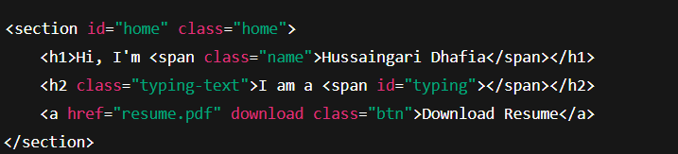
Fig. No. 5.1.1 Code Snippet for Home Page Layout

5.2 NAV BAR
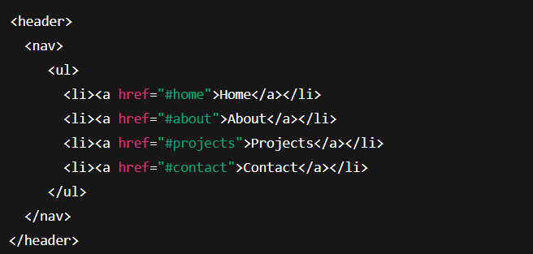
Fig. No. 5.2.1 Code Snippet for Home Nav Bar
Creates the website menu
Clicking on menu links scrolls to each section using smooth scrolling (handled by JavaScript + anchor links)

5.3 ABOUT SECTION
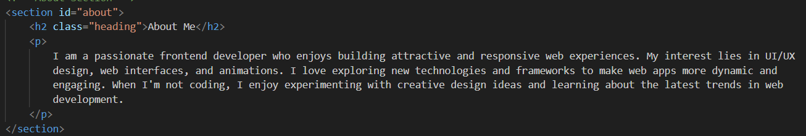

Fig. No. 5.3.1 About section

Displays your photo + description
about-content organizes paragraph and title

5.4 PROJECTS SECTION
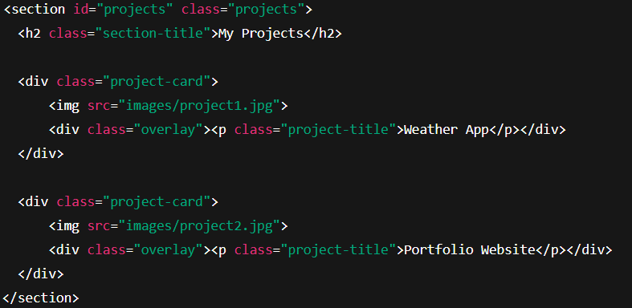
Fig. No. 5.4.1 Code snippet of project section

Each project is shown as an image
Overlay appears during hover → shows project name

5.5 CONTACT SECTION
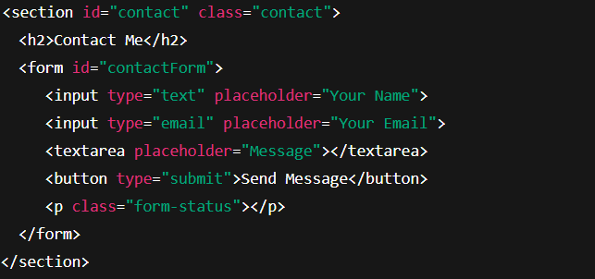Fig. No. 5.5.1 Code Snippet for contact Section

5.6 FOOTER SECTION(SOCIAL MEDIA ICONS)

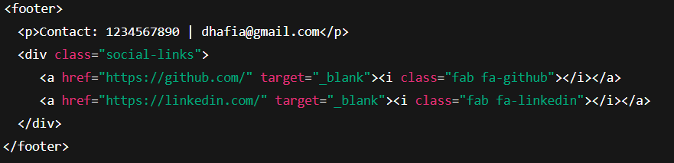
Fig. No. 5.6.1 Code Snippet for Social media icons
Shows phone + email
GitHub and LinkedIn icons open in new tab

5.7 GLOBAL STYLING

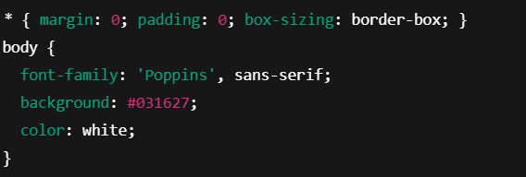

Fig. No. 5.7.1 Code Snippet for Global section

5.8 NAVIGATION BAR STYLING
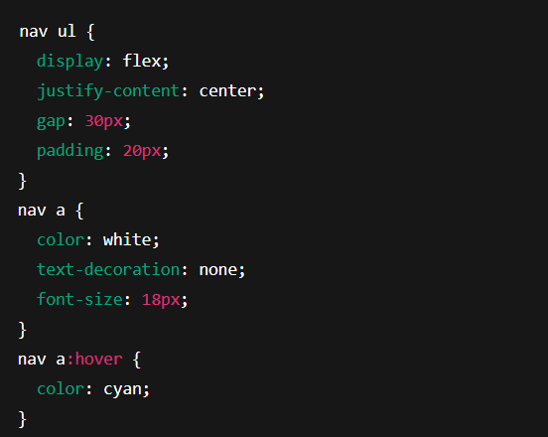
Fig. No. 5.8.1 Nav bar style

5.9 HOME SECTION STYLING
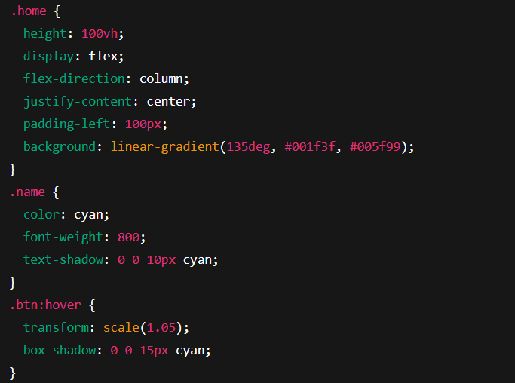
Fig. No. 5.9.1 Home style
Flex layout places the image and text neatly side-by-side. The circular glowing profile picture immediately grabs attention and adds personality to the page.
5.10 PROJECT SHOWCASE STYLING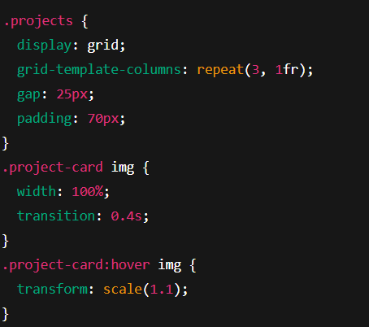
Fig. No. 5.10.1 project showcase style
The grid layout arranges the project cards evenly and responsively. The zoom effect on hover highlights each project visually without clicking.
5.11 OVERLAY EFFECT STYLING

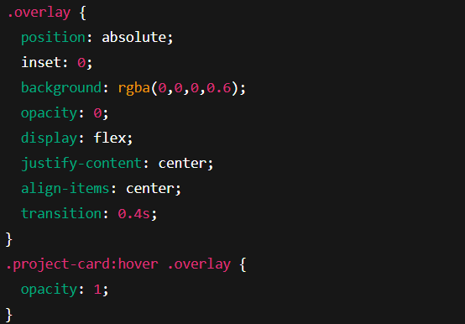
Fig. No. 5.11.1 Overlay effect

The overlay stays hidden initially and fades in smoothly during hover. This technique helps reveal the project name in a stylish and interactive manner.

5.12 CONTACT FORM STYLING
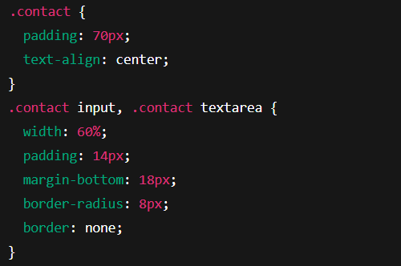
Fig. No. 5.12.1 Contact form

Inputs and text areas are wide and rounded to make typing comfortable. Centered alignment and spacing ensure the contact form looks clean and user-friendly.

5.13 FOOTER AND SOCIAL MEDIA ICON
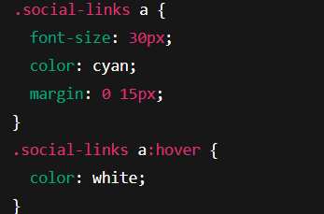
Fig. No. 5.13.1 Footer and icons

Large icons with wide spacing make each social platform stand out clearly. The color change during hover gives smooth visual feedback and improves engagement.

5.14 RESPONSIVE DESIGN FOR MOBILES
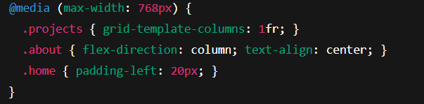
Fig. No. 5.14.1 Responsive design
On smaller screens, layouts automatically shift to a single-column format for readability. This ensures the portfolio looks perfect on phones, tablets, and laptops.

5.15 TYPING ANIMATION
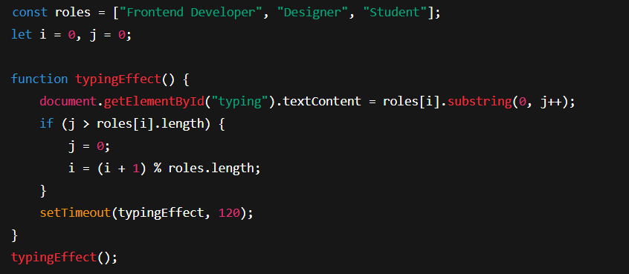
Fig. No. 5.15.1 Typing animation
This code prints each role letter-by-letter inside the typing span, creating a continuous typing animation. Once a word finishes typing, the next one starts automatically.
5.16 CONTACT FORM STATUS MESSAGE
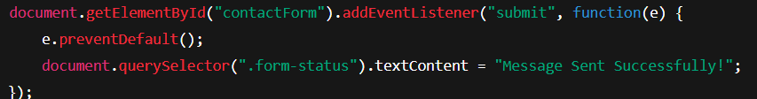
Fig. No. 5.16.1 Form status message
When users click "Send Message," the page does not reload. Instead, JavaScript instantly shows a success message giving a smoother experience.
5.17 SMOOTH SCROLL
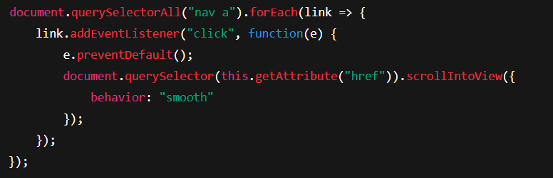

Fig. No. 5.17.1 Smooth Scroll
This code makes navigation feel professional by gently scrolling to the section instead of jumping abruptly.
CHAPTER 6

RESULTS

6.1 HOME PAGE OUTPUT

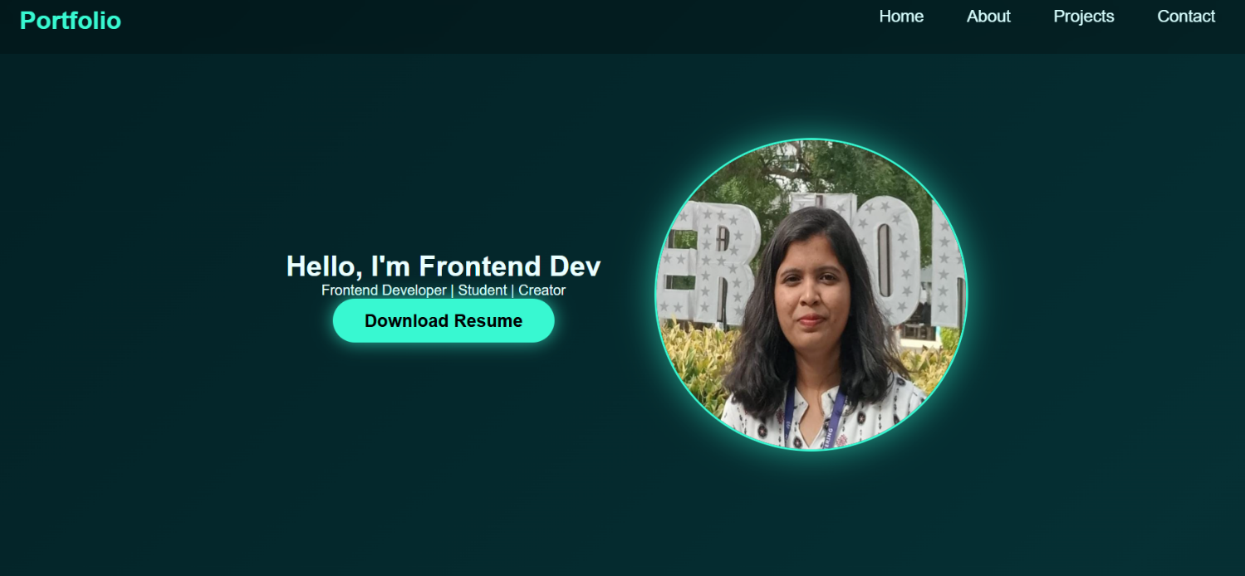

Fig. No. 6.1.1 Output of Home Page
The Home page displays the portfolio owner’s name and professional roles through a JavaScript-based typing animation [3]. A navigation bar provides access to other sections including About, Skills, Projects, and Contact. The visual theme includes a modern dark interface with glowing text and responsive alignment.

6.2 ABOUT SECTION
The About section presents a summary of background information, academic details, and technical interests. The layout is aligned using CSS Flexbox [2], offering a clean visual appearance and proper spacing between the profile picture and text.

Fig. No. 6.2.1 Output of About Section

6.3 PROJECTS SHOWCASE
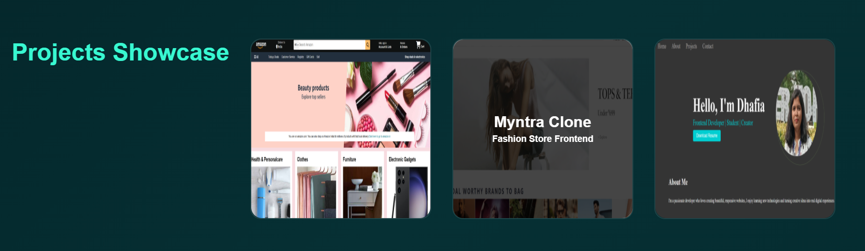

Fig. No. 6.3.1 Output of Projects Section

This is the key highlight of the website. Each project image is placed inside a grid created using CSS [2]. When the cursor is placed over a project image, the project title becomes visible through smooth transition and overlay animation [6]. This improves engagement and gives a professional appearance to the portfolio.

6.4 CONTACT SECTION

The Contact section allows visitors to submit queries through a simple form. When the user clicks the send button, JavaScript automatically displays a success message without reloading the page [3]. This provides a smooth and interactive user experience.

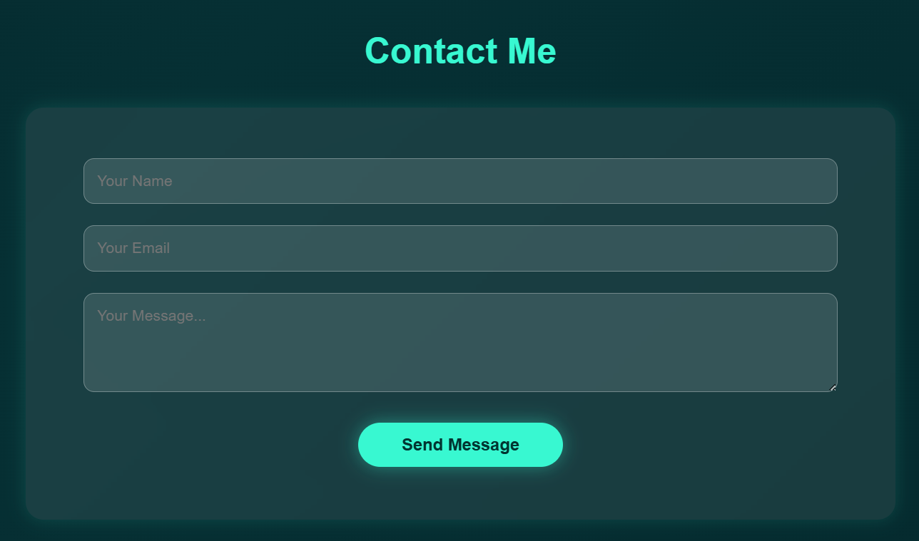

Fig. No. 6.4.1 Output of Contact Page

6.5 FOOTER SECTION


Fig. No. 6.5.1 Footer Section

The footer section contains clickable Font Awesome icon links that redirect to the user’s GitHub and LinkedIn profiles [5]. This makes the portfolio effective for professional networking and job opportunities.
6.6 RESPONSIVENESS RESULT

The responsive layout ensures proper scaling of elements across multiple screen sizes using CSS media queries [2]. All sections remain readable and aligned even on mobile devices, proving that the website is device-independent.
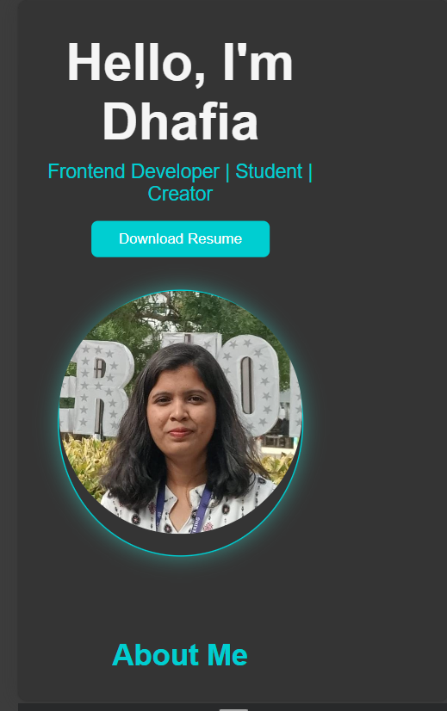

Fig. No. 6.6.1 Output of Responsive View on Mobile

CHAPTER 7

CONCLUSION

The mini-project titled “Portfolio Website with Image Hover Effects” successfully achieved its objective of creating a visually appealing, interactive, and responsive digital platform for presenting personal and professional information. The website demonstrates the effective use of HTML for structural layout [1], CSS for user interface design, hover animations, and responsiveness [2], and JavaScript for dynamic interactivity and user engagement [3]. External API services, including Google Fonts for typography [4] and Font Awesome Icons for professional social media integration [5], enhanced the overall design and usability of the system.
The implemented hover effect in the Projects section serves as the primary highlight, allowing project titles to be revealed interactively when users place the cursor over project thumbnails. Additional features such as the typing animation, résumé download button, and functional contact form improve accessibility and make the portfolio suitable for academic evaluations, internship applications, and recruitment purposes. Cross-device responsiveness ensures that the layout remains well-structured across desktops, tablets, and mobile devices, demonstrating the efficiency of CSS grid and media queries.
Overall, the project demonstrates how modern web development practices can transform conventional static résumés into a highly engaging and professional digital interface. The system not only fulfils its academic requirement but also provides a practical and career-boosting tool that can be updated and reused beyond the scope of this project.

REFERENCES

[1] W3Schools. (2024). HTML Tutorial.
Retrieved from https://www.w3schools.com/html/

[2] W3Schools. (2024). CSS Tutorial.
Retrieved from https://www.w3schools.com/css/

[3] Mozilla Developer Network. (2024). JavaScript Documentation.
Retrieved from https://developer.mozilla.org/

[4] Google Developers. (2024). Google Fonts API Documentation.
Retrieved from https://fonts.google.com/

[5] Font Awesome. (2024). Font Awesome Icons API.
Retrieved from https://fontawesome.com/

[6] Netlify. (2024). Netlify Deployment Documentation.
Retrieved from https://www.netlify.com/

[7] Canva. (2024). UI Design Inspirations.
Retrieved from https://www.canva.com/

